It’s a new year! You probably have new classes, new students, and lots of change. Before your students can get started on Achieve Literacy, you need to make sure your students are setup properly. For students who are new to your building, this means assigning new usernames and passwords as well as associating them to their classes. For students who already used the program last year, it just means moving them over to their new classes. Whatever the situation, follow these simple steps to set up your new students and classes. It’s as easy as 1-2-3!

# Step 1 – Create teacher logins

Before they can set up their classes, each participating teacher needs a login to Achieve Literacy. Teachers who used the program last year can continue to use the same login name and password. Teachers who are new to the program will need new logins.

If your teachers have logins and passwords already, you can skip this step. Otherwise, the simplest way to set up your new teachers – and to get the login information for existing teachers who may not remember their passwords – is to send Achieve3000 a complete list of all your current teachers. Send your list, in an Excel file, to [rostering@achieve3000.com. **P**](mailto:rostering@achieve3000.com)**lease indicate each teacher’s first and last name, as well as the grade level that he/she will be teaching this year in an Excel File.** Also include the names of any staff that you would like to set up as a school administrator, and indicate that they are administrators. Note that we recommend that you designate at least one administrator – generally a computer teacher, assistant principal, or principal.

We’ll get back to you within three business days with a complete list of logins and passwords for your teachers.

# Step 2 – Set up your classes

Once your teachers have logins and passwords, they are ready to get to work setting up their classes in Achieve Literacy. They should follow these steps:

1. Log in to your Achieve3000 Teacher’s Edition ([http://portal.achieve3000.com](http://portal.achieve3000.com/)).
2. If the Setup Wizard pops-up proceed to Step 6.
3. Click your name at the top of the screen.
4. Click Admin Settings.
5. You will either see *Launch Setup Wizard* or a list of options.
   1. If you see a list of options, click the *Add users to my class* link. The Setup Wizard will now appear.
   2. If you only see *Launch Setup Wizard,* click on the link.
6. In the Setup Wizard, review the list of classes.

If you prefer, you can send Achieve3000 the list of students who are new to Achieve Literacy. This way, your teachers won’t have to enter them into the system manually. Contact [rostering@achieve3000.com](mailto:rostering@achieve3000.com) for details.

<https://helpcenter.achieve3000.com/hc/en-us/articles/360062878653-One-Time-Manual-Upload>

* 1. If your class name appears on the list, select it, and click *Next*.
  2. If your class does not appear, click *Create New Class*.

1. Type in or confirm the information that appears and click *Next*. (All fields with asterisks are required.)
   1. Default Homeroom – Students are now required to select the class they want to work in when they first log into the program. You can check the Homeroom box if you would like this class to be the default class that appears first on the student’s class list.
   2. Dual Language Classes – Teachers have the ability to create dual Spanish and English accounts for their students. By selecting English/Spanish under Dual Language, two classes will be created in the system, one for English, and one for Spanish. Depending on which class students select when they login will set their language setting appropriately.
2. The next screen may offer two choices. Click ***Create Permanent Logins***.

A list of members of the class appears. If there are students in the class who do not belong there, select their name/s and click *Remove*. Note that the students will be removed from this class only – they will not be deleted from the system. Also note that your name will appear in red, this means you are the teacher in this

class, do not remove your name.

1. Click *Add* to begin adding students and/or teachers to your class.
2. Add each of your students/teachers to your class. There are three ways to add users to your class:
   1. Use the Browse utility on the left-hand side of the screen. Select the student from the list. Then click *Add to Class*. By default, the *All Recent Users* tab is displayed when the page loads. This tab shows users from this year and last year. If you prefer not to see last year’s users you can click the *Current Users Only* tab. *Current Users Only* tab shows just users who are new for this year (users who were just loaded, and users who have already been associated to brand new classes).
   2. Use the Search utility on the right-hand side of the screen. Type as much information as you can about the teacher or student. Students and Teachers who have used the program at another school in your district can be found here. Use the drop-down menu next to School to locate users at different schools. Then click Find User. Locate the teacher/student and the click Add to Class.
   3. 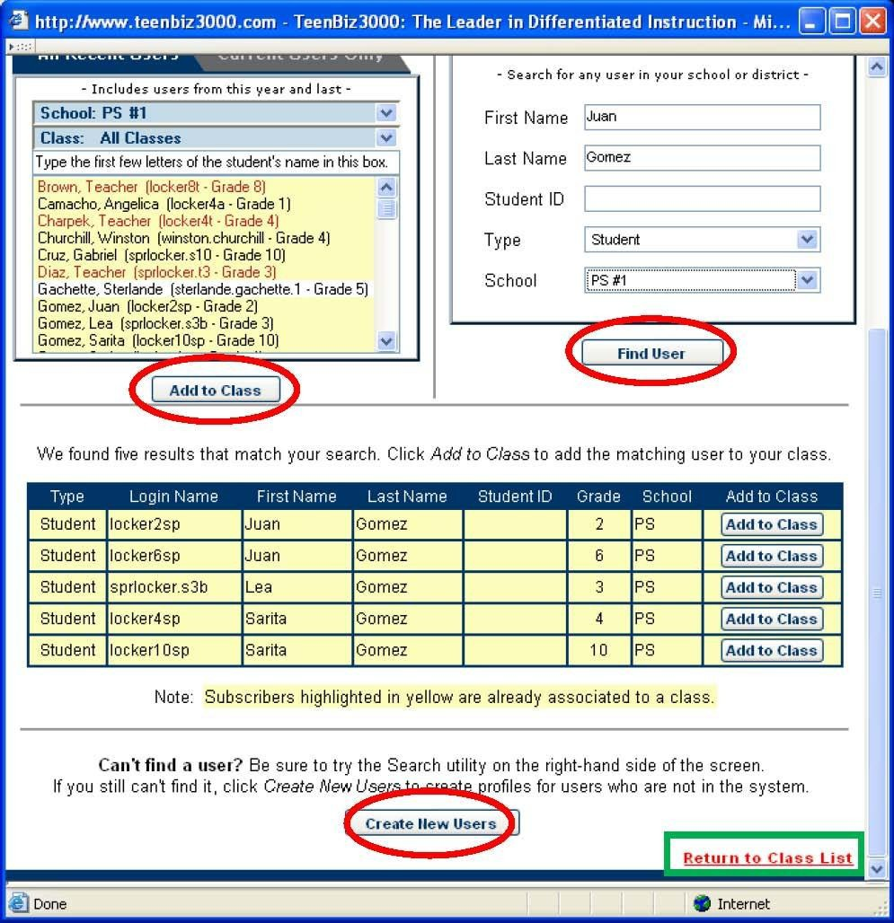If you can’t locate a user using the Browse or Search utility, Click Create New Users at the bottom of the screen. You must enter a student ID number when adding a new student to the program. NOTE that teachers whose students did not use the program last year will need to enter all of their students here. All fields with asterisks are required. Click Save Changes and Close at the bottom of the page.
3. When you are finished adding students, click *Return to Class List*. (All changes will be lost if this link is not clicked.)
4. Then click *Next*.
5. Review the list (Class Members’ Information), and make corrections if needed. Make sure that the grade level of each student matches the grade level of the class you created. (The *Status* column indicates which users are ready to be added to your class. If you see any students within their status column, click the box to verify the user information.)
6. Click *Finish* when you’re done. **This step is critical for saving the information in our system.**

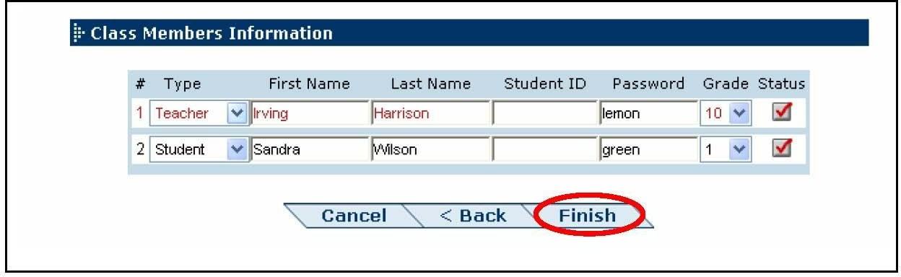

1. Print your class list, if desired. This will make it easier to distribute the passwords to your students. To set up additional classes, click *Set Up Another Class*. Otherwise, click *Close*.

# Step 3 – Remove old classes and confirm that new ones are set up correctly

As a final step, we recommend that you log in using an administrator password to confirm that the classes have all been set up correctly. Deleting classes that no longer exist ensures that the reports that Achieve3000 delivers to school and district administrators are accurate.

1. Click your name at the top of the screen.
2. Click Admin Settings. Then click class in the Edit school or class information option.
3. A list of classes appears.
4. Review the list and check for the following:
   * *Are any classes missing?* If so, have the teacher follow the procedure above (in *Set Up Your Classes*), to set up this class.
   * *Are any classes on the list, that shouldn’t be?* For instance, are there classes on the list who aren’t using the program this year, or that no longer exist? If so, check the box to the left of the class, and click *Delete Classes* at the bottom of the screen. Note that the users in those classes won’t be deleted. Click OK.
5. On the right-hand side of the screen, in the *Users* column, click *Edit* to access the list of students and teachers in one of your classes. Spot-check the list to be sure it includes current students only. You may want to repeat this step for a few classes.
6. Once you’re satisfied with your classes, you’re ready to start using the program.

# Frequently Asked Questions

***I have new students in my building. How do we get passwords for them?*** You have two choices. Either you can send Achieve3000 their information and we can add them (contact [rostering@achieve3000.com f](mailto:%20rostering@achieve3000.com)or information about this option). Or you can have your teachers enter their names manually when they go into set up their classes (see the note in the sidebar next to step 7 in section 2, above). It’s up to you.

***Can we add students to more than one class?*** Sure. Follow the same steps as you would if they belonged to just one class. Have teachers use the setup wizard to pull the students into their classes. They can be added to as many classes as you like. If students belong to more than one class, they will be prompted to select a class when they log in.

**How should we name our classes? Does Achieve3000 recommend a particular naming convention?** Name your classes however you like, but try to use the same convention across the entire site, for consistency in reporting and so that students can recognize and remember their class names. Most schools use a combination of grade, teacher and/or room number. For example, 6-Smith, for Mr. Smith’s sixth grade class. Or 6-103, for the sixth grade class in room 103. Note that there is a 25 character limit for class names.